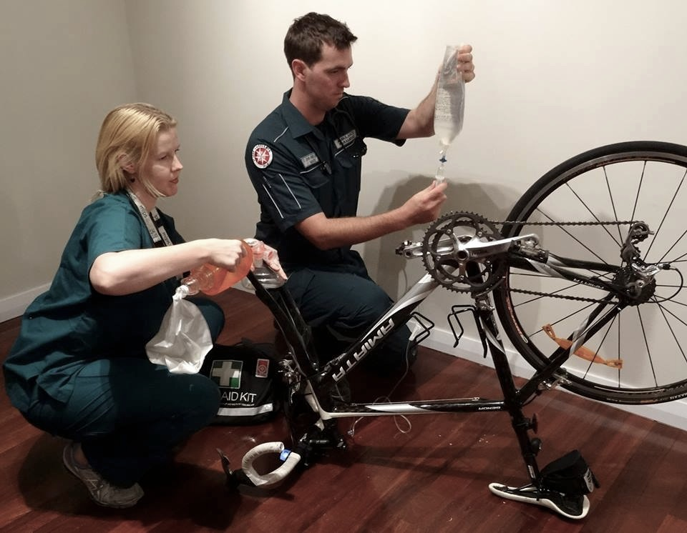

**Quiz Night**

**Date:10th May**

**Time: 7:00 to late**

**Cost: $20.00 per head with all money going to the Cause.**

**BYO platters of food and alcohol is permitted but will NOT be available for sale.**

**Contact Donna: 0423506911 to book a table or more Information and follow us on Facebook:**

**Carcinoma Cure-ologists Ride to Conquer Cancer**